Game Design Document
GameName
TeamName

Note: Anything that is italicized is to be removed/replaced with the relevant information of your team and game. Certain sections will only be relevant starting from Beta and have been labeled accordingly.

Team Members
Name | Roles | E-mail & GitHub ID
Kuan-Yu Chen  <Photo1> | Team Captain/User Interface | kchen791@usc.edu  Github ID 1:nm666code
John Tu  <Photo2> | Stenographer/Physics/Gameplay | jytu@usc.edu  Github ID 2: johnt759
Ting-Wei Hsu  <Photo3> | Product Manager/System (Analytics) | thsu3236@usc.edu  Github ID 3: hsutimwei
Tianao Lan  <Photo4> | Tools/System | tianaola@usc.edu  Github ID 4: lantianao
Yen Chiang  <Photo5> | Level Design/Artificial Intelligence/Enemy Control | yenchian@usc.edu  Github ID 5: YenChiangRobert
etc… | etc… | etc…

Note: Everyone is expected to code. It’s a good idea for more than one member to take notes, especially in the event the stenographer is absent.
Reference: https://docs.google.com/spreadsheets/d/19x6akdW9RwzO38-ekCTLAEhYWjL3jlIjfkWYMMVDHmk/edit?usp=sharing

<Optional Group Photo>

Links
Unity Project GitHub Repository | https://github.com/nm666code/SunlightSurvivors
Playable Alpha Progress Check Build | link
Playable Alpha Build | link
Alpha Gameplay Video | link
Alpha Survey | link
Playable Beta Build | link
Beta Gameplay Video | link
Beta Survey | link
Playable Gold Build | link
Gold Gameplay Video | link

Note: It is required to have different build links for each of these sections. Do NOT overwrite a previous build with a new one as it will cause issues during grading.

Game Introduction

Logline
Logline - Our game is a Vampire Survivors-like game where players must survive waves of enemies while avoiding dynamically shifting sunlight.
(Do not literally write “Infinite Runner + dimension swapping”)

Player Goals / Win Conditions
The player’s goal is to survive waves of enemies until the final boss appears and defeat it to win the game.

Game Description
(1-2 paragraphs. No more than half a page. Must be about gameplay and the mechanics currently implemented, nothing about narrative/story.)
Our game is a Vampire Survivors-like survival game where the player must survive continuous waves of enemies while avoiding dynamically shifting sunlight that creates dangerous areas on the battlefield. The player automatically attacks nearby enemies, collects experience, and chooses new abilities and upgrades as they level up.
As the game progresses, enemies become stronger and the sunlight changes the available safe space, forcing the player to constantly reposition and adapt their strategy. The player must balance movement, combat, and ability choices to survive until the final boss appears and defeat it to win the game.

Controls
Movement: W,A,S,D
Attack: Leftclick
Use items: 1,2,3,4
Reference: https://docs.google.com/document/d/1cPECaMYiPAJHokJezwWc-eo06oltawHrwEv5m0hkOLo/edit?usp=sharing

Detailed Design
This section is essential in communicating what your game is all about both within the team and with teaching staff.

Game Mechanics (How to Play)
Movement mechanic: Use the keyboard or mouse to aim and fire the dart.
Score mechanic: Gives point when hitting target
Fall mechanic: Cannot hit all targets in the given time.

Game Mechanic Research
<Game mechanic 1>
Game Title | Game title
Mechanic/System | Name or type of mechanic/system of interest
Interest | Why is the mechanic /system of interest/relevance to you?
Interaction with other mechanics | How does this mechanic interact with other mechanics in the above mentioned title?
Innovation | How can you twist the game genre and innovate on this mechanic?

Mechanic research for an Upgrade System .
Game Title | Archero
Mechanic/System | Ability Selection / Upgrade System
Interest | Archero periodically lets players choose from a set of abilities, allowing them to create different builds during each run. We are interested in how these choices make each run different and encourage players to adapt their strategy.
Interaction with other mechanics | The ability system directly affects combat, movement, and survivability. Different upgrades can increase damage, change attack behavior, improve mobility, or interact with other abilities to create stronger combinations.
Innovation | We want to twist this system by making upgrades come with environmental consequences. Choosing stronger abilities may sacrifice or transform parts of the floor into hazardous tiles, gradually reducing the player's safe space.

Game Title | Hades
Mechanic/System | Temporary Powerups that lasts for the duration of the run
Interest | This mechanic is interesting given that it provides the player some powerup boosts to handle more difficult foes and hazards towards the end of the run. If the player is defeated, the run is over, and all temporary powerups are lost.
Interaction with other mechanics | It allows the player to customize their playstyle and build, and no subsequent run will be the same given the possible combinations of temporary powerups the player can select.
Innovation | A possible innovative twist is to give players any unique one-time powerups that will be offered to the player based on the combinations of the temporary power-ups (and possibly one-time permanent capstone boosts).

Game Title | Dishonored
Mechanic/System | Blink teleportation, time freeze, body possession and other skills
Interest | It gives the player freedom in movement and supports both stealth and combat and other interaction
Interaction with other mechanics | mechanicsIt interacts with stealth, enemy vision, vertical level design, assassination, and other supernatural powers.
Innovation | A possible twist is to make teleportation leave behind a temporary “echo” of the player. Or we can possess an enemy while get its ability

Mechanic research for ??(Tim)(Do it tomorrow)
Game Title | Game title
Mechanic/System | Name or type of mechanic/system of interest
Interest | Why is the mechanic /system of interest/relevance to you?
Interaction with other mechanics | How does this mechanic interact with other mechanics in the above mentioned title?
Innovation | How can you twist the game genre and innovate on this mechanic?

Game Title | Brotato
Mechanic/System | Arena Pressure / Enemy Wave System
Interest | Brotato places the player in a limited arena while increasingly large enemy waves restrict movement and force constant repositioning. We are interested in how environmental space itself becomes an important resource as enemy pressure increases.
Interaction with other mechanics | The wave system interacts directly with movement, weapons, enemy density, and survivability. As more enemies enter the arena, players must balance positioning and attacking while searching for safe areas to move through.
Innovation | We want to combine enemy pressure with a dynamic hazard grid. Certain rows or columns of the arena will periodically become dangerous, while temporary safe platforms appear elsewhere. This forces players to avoid both enemies and environmental hazards. Some upgrades may eventually allow players to use hazardous tiles against enemies, turning environmental danger into an offensive tool.

Reference: https://docs.google.com/document/d/1F9TSZNNnNx8Rouu0acmTBBkWL2K40ZLDnfBK2eyDYqs/edit?usp=sharing

Matrices

Twist & Mechanics Matrix

Mechanics | Description | Interaction with Twist | Affected Genre Elements | Supports
Core Mechanics
Mechanic A
Mechanic B
Mechanic C

Mechanic Interaction Matrix

Subject / Object | Mechanic 1 | Mechanic 2 | Mechanic 3 | Mechanic 4
Mechanic 1
Mechanic 2
Mechanic 3
Mechanic 4

Single Mechanic Challenge Matrix (Beta)

Challenge | Location | Difficulty | Player Must Learn | Instructions | Required Skills

Reference: https://docs.google.com/document/d/1uQM8zxFoVxNjrwvtTKShn0noUwmgLENSY-PXc9VyMiI/edit?usp=sharing

Tutorialization implementation for Mechanics (Beta)
Add your tutorialization plan for each of the mechanics within your game

Sketches and Diagrams

Gameplay Loop
Example image:
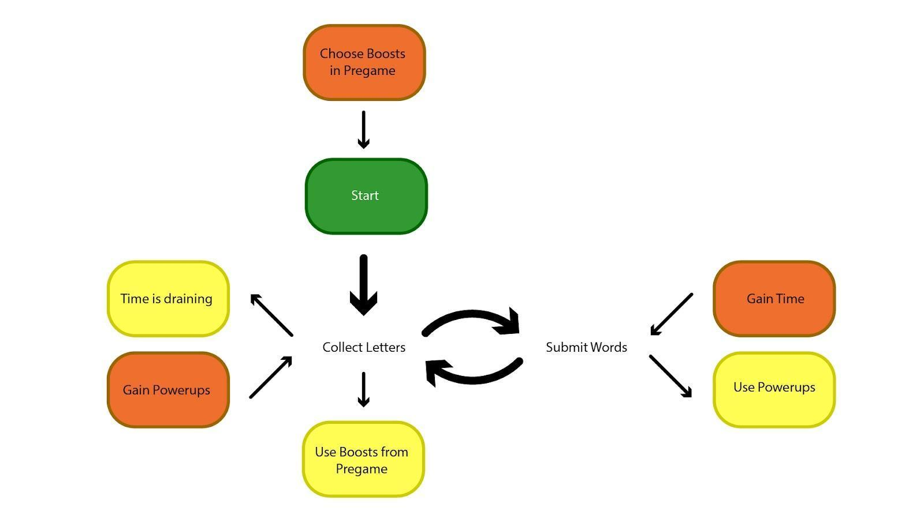

Mechanic/Level Sketches
Add sketches / screenshots depicting mechanics incorporated and ideas you’d like to implement in the future.

Level Designs (Beta)
Example sketch:
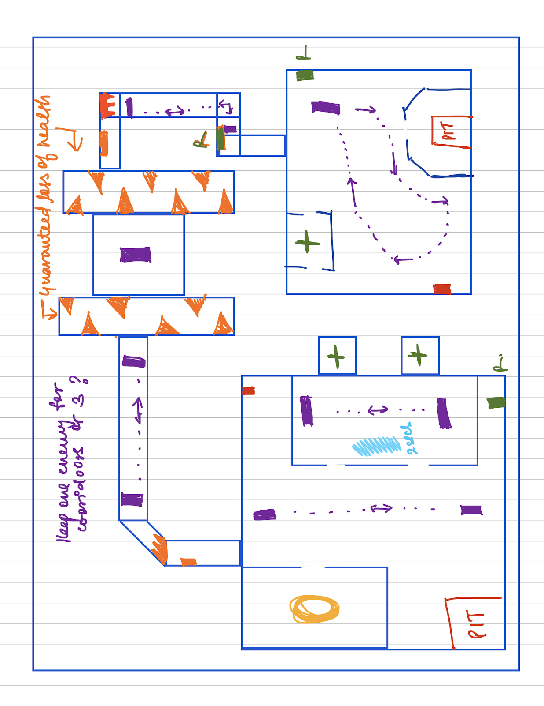

Example image:
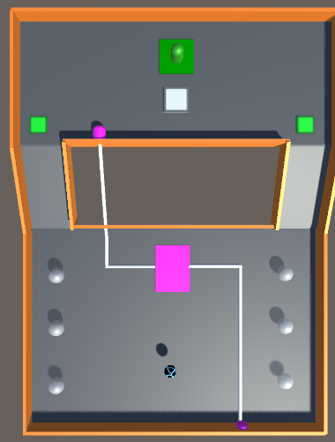
Level 5: The player has to avoid a deadly orb

Concept Art
Example image:
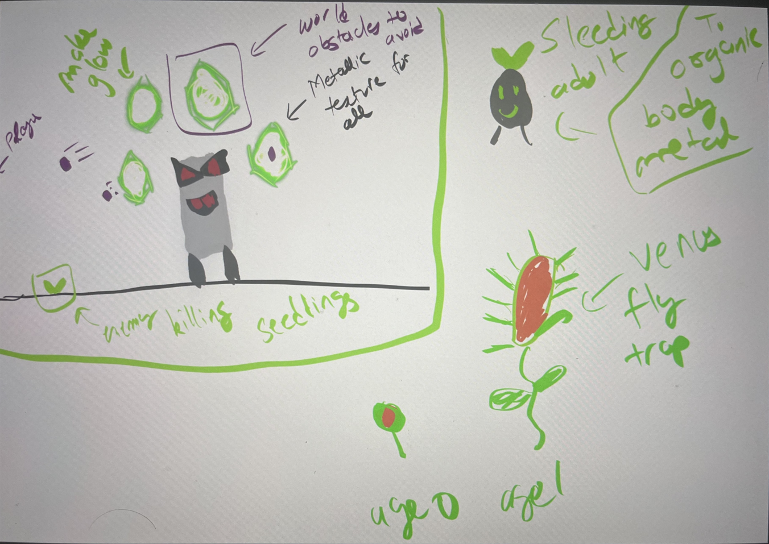

Game UI - (Beta)

Menus
Add screenshots of Title screen and Level selection if present.

HUD
Add screenshots of HUD elements used within your game.

UI Flowchart
Add a flowchart indicating how the player goes through different menu and level screens in your game.

Analytics
Methodology Used:
Example:
- Data Collection:
  - Used xyz to track metrics
  - Link to data collection
- Data Visualization:
  - Used xyz scripts to generate abc

Metrics
Metric #1: Name of metric
Description: Brief description of the metric

(Mockup Sketch of hypothesized analytics/ Image of actual results)
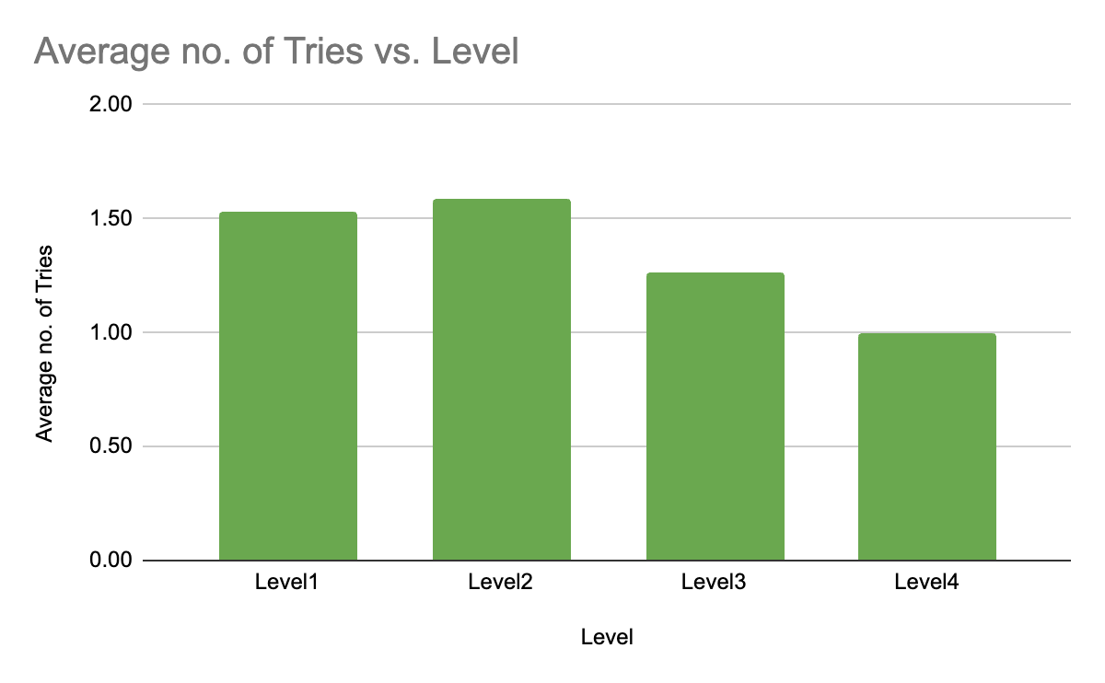
Justification:
Why was this metric chosen? How will it provide insightful data and how will this data be used to improve your game?

Interpretation:
List possible results you might obtain with this analytic. What would each of these results suggest about your players and mean for your game?

Hypothesis:
List testable hypotheses based on the data you have collected. What could be the cause of variations in your data, and can this cause be modified in your game to yield different results?

Weekly Prototype Descriptions
Describe each of your weekly prototypes here, noting additions, changes, and improvements. It is important to keep this updated every week. Add a few screenshots from each week's development.

Week-8:
- Designed mechanic A which works in xyz way
- Initially X was placed in Z format. Changed it to Y to accommodate mechanic B.
<Add images from your game and explanations>

Week-9:
- etc….

Weekly Progress
List the individual work done by each team member up to that week in the table below. Add short descriptions of the work done and add a link to one relevant Github commit for the respective work done by that team member.

Week Number | Team Member
Week 8 | Team Member 1 | Team Member 2
Week 8 | Mechanic 1 implemented  <Link to one relevant Github commit> | UI element  <Commit link>
Week 8 | Team Member 3 | Team Member 4
Week 8 | Level Design  <Commit link>
Week 8 | Team Member 5 | Team Member 6
Week 9 | Team Member 1 | Team Member 2
Week 9 | Team Member 3 | Team Member 4
Week 9 | Team Member 5 | Team Member 6

Note: This is to be followed for the rest of the semester. Make sure it is updated each week.

Review Notes
Notes/feedback that you receive from staff and playtesters, as well as possible improvements you could make based on it. It is important that the stenographer makes note of these each week, but other team members should also keep track of incoming feedback.

[Playtest 1 ??/??/2026]

- They had a hard time understanding how to climb
- They got stuck on level 2’s third challenge for ten minutes
- They expressed annoyance every time they died and had to restart a level

[<Milestone> Playtest results]

- Analytics
  - 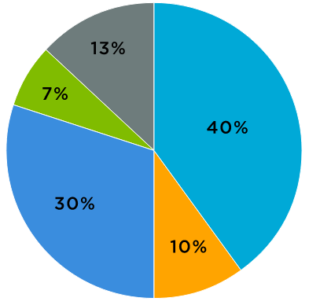
    - 40% of deaths were caused by trap A. 30% were caused by trap B. The remaining 30% were caused by all the other traps

- Survey
  - Five players said that level 2 was too hard
  - Ten players said their least favorite part of the game was its controls

[Playtest 2 ??/??/2026]

- They missed the super powerup in level 1
- They kept dying in the fourth challenge of level 3
- They’re performing better at puzzles than platforming challenges

[Staff Feedback]

- The game’s too challenging for novice platformers right now
- We don’t have enough tutorialization for our obstacle mechanics

Hypothesized Issues from Feedback (Gold)

Hypothesized Issue #1
Trap A and its challenges are too difficult for players.

Significance
Since Trap A is used extensively across multiple levels and challenges in our game, players tend to get stuck and cannot proceed due to it being imbalanced.

Feedback/Data points
- One playtester got stuck on level 2’s third challenge for ten minutes (first use of trap A) indicating poor tutorialization of the mechanic.
- 40% of recorded deaths were caused by trap A according to metric #2. It shows trap A causes vastly larger deaths than the second highest cause, death by falling, at 20%.
- Five players in the survey said that level 2 was too hard. Level 2 introduces trap A and has a few challenges associated with it and an early difficulty can signify a lack of mechanical understanding.
- Eight players reported that they kept dying to level 3’s fourth challenge (uses trap A extensively).

Potential Fixes
- Add more tutorialization to teach trap A more gradually
- Introduce trap A later in the game once the player is more skilled

Implemented Solution
We moved the current Trap A challenges to later in the game and introduced easier challenges early on to ease the player into learning the mechanic. This solution was chosen to increase tutorialization of the mechanic in a low-risk environment, with challenges that require a deeper understanding of Trap A gradually appearing.

We can test the efficacy of this adjustment by creating a graph of deaths caused by Trap A per challenge and observing whether the curve is smoother than it was before the fix.

<Add images/screenshots showing gameplay before and after implementation of the fix>

External References
Link to any references (tutorials, assets, etc) from other sources used in your game here. Explicitly state how they are used.
Note: You get credit solely for what you have developed yourselves. Assets will not count towards the grade and must be mentioned below.
If external assets / code / tutorials are used without reference, you will incur negative consequences.

Name | Link | Usage
Endless Runner - Sample Game | https://assetstore.unity.com/packages/essentials/tutorial-projects/endless-runner-sample-game-87901 | We used the entire asset as the basis of our own game. Specifically,  - Lanes  - Concept of Lanes  - Switching Lane by Swipe  - Coin System  - Pick up Coins  - UI  - Health System  - Colliding with Obstacles  - Health  - UI  - Score System  - Picking up items  - UI  - Obstacles  - Jump to avoid  - Collision with obstacles  - Power up System  - Grant invincibility when power up is picked up  - Character System  - Character Select  - Character Unlock  - Map/Level System  - Map Select  - Setting  - Leaderboard  Here is a video link to what the game looks like:  https://www.youtube.com/watch?v=gc3RFaU5tH0
Unity NavMesh Tutorial - Basics | https://www.youtube.com/watch?v=CHV1ymlw-P8 | Learned how to make AI agents move along a navmesh and follow the mouse’s clicks
Finite State Machines | https://learn.unity.com/tutorial/finite-state-machines-1 | Learned how to implement AI state machine through object inheritance and polymorphism

Appendix

Misc
Other miscellaneous information if any.

